Analysis of Coupons

“Will the Customer Accept the Coupon?”

By Rajesh Radhakrishnan

(09/30/2024)

The coupons dataset contains survey data of different drivers who are sent coupons to Bars, Coffee Houses, Restaurants (cheap and expensive) and Take-Away. The driver/customer is then recorded as accepting the coupon (right away or later before the coupon expires) or rejecting it.

**Problem Statement**: Distinguish between customers who accepted a driving coupon versus those that did not.

Two coupon types were analyzed in this analysis – Bar coupons and Coffee House coupons.

**Findings**:

(a) **Bar Coupons**: The customers who visited Bars 1 or more times a month are seen to have a higher Bar coupon acceptance rate. The majority of customers who rejected the Bar coupons never visited Bars. Customers with age greater than 25 years are more likely to accept a Bar coupon when compared to all others. The acceptance rate is lower for those with incomes less than 50K and who go to cheaper restaurants 4 or more times a month. Thus, customers who accept Bar coupons are those with higher frequency visits to the bars whereas customer who decline the coupons are those that are less frequent to Bars or have lower incomes. Single customers are more inclined to accept Bar Coupons whereas those Married or having a Partner are more likely to reject the Bar coupons. Unemployed customers have the highest propensity to reject Bar Coupons. Students are more likely to accept them. Also, customers who accept Bar coupons typically do so when the weather is Sunny.

(b) **Coffee House Coupons**: A majority of Coffee House coupon customers never visited Bars. The largest number of customers went to expensive restaurants less than once a month, and went to take-away as well as cheap restaurants 1 to 3 times a month. The acceptance rate for Coffee House coupons is higher for those who go to coffee houses once or more per month (the largest acceptance rate was seen for those who went 4-8 times a month). Among these customers, the acceptance rate was higher when the passengers were Friend(s) or Partners as compared to driving Alone or with Kid(s). A larger proportion of Female drivers/customers (compared to Male counterparts) who accepted the Coffee House coupon visited the coffee houses 1 to 3 times a month, as well as 4 to 8 times a month. Also, the coffee house coupon customers had the highest acceptance rate when they were not headed to their Home or Work destination. The largest acceptance rate of coffee house coupons was when they were sent out at 10AM.

Charts:

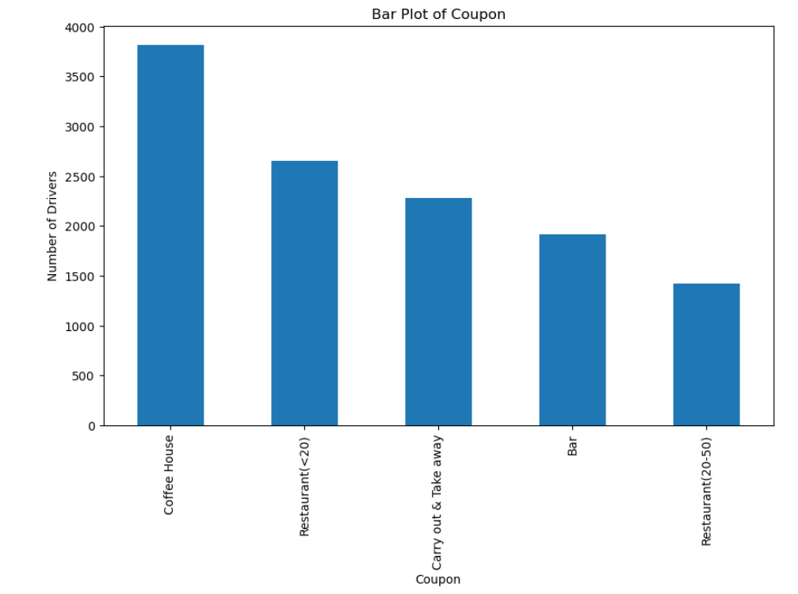

The number of coupons in the data – the largest number are Coffee House coupons.

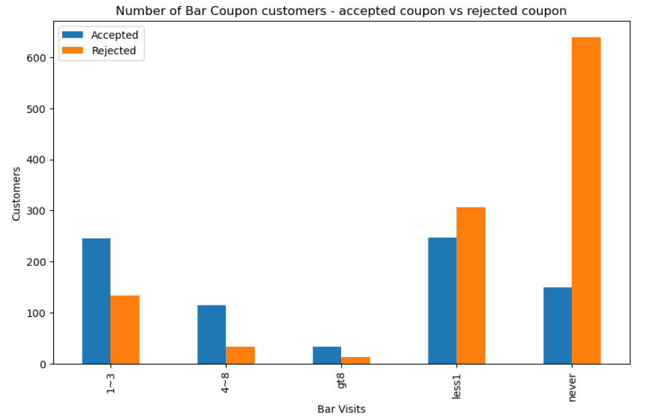

The majority of customers who rejected the Bar coupons never visited Bars. Those who visited Bars 1 or more times have a higher rate of acceptance of the Bar coupon.

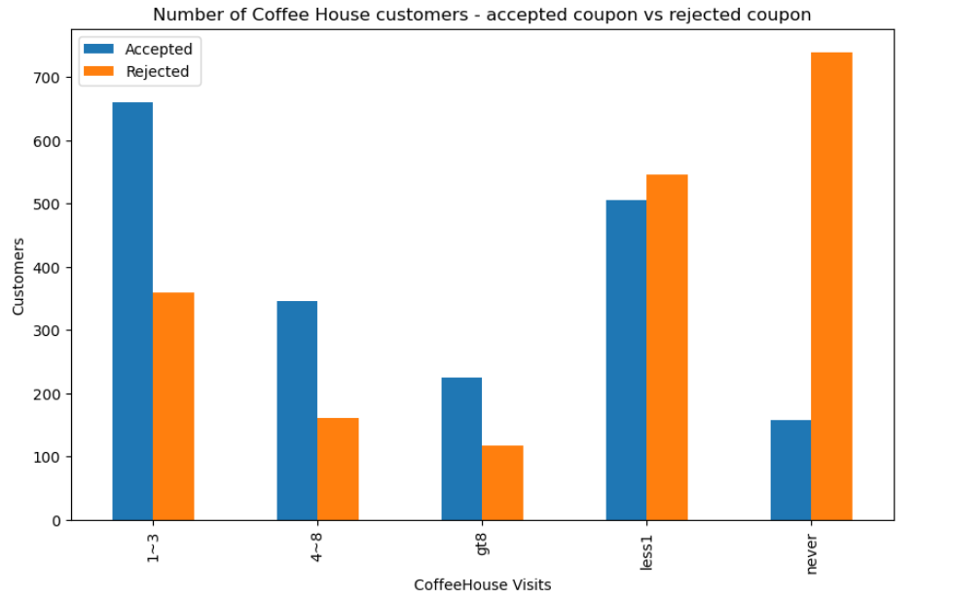

The majority of customers who rejected the Coffee House coupons never visited Coffee Houses or went there less than once a month. Those who visited Coffee Houses 1 or more times have a higher rate of acceptance of the coupon.